Họ và tên: Nguyễn Đình Khánh Vy
MSSV: 22161043
Laboratory Exercise 1
DISCRETE-TIME SIGNALS: TIME-DOMAIN REPRESENTATION
1.1 GENERATION OF SEQUENCES
Project 1.1 Unit sample and unit step sequences
% Program P1_1
% Generation of a Unit Sample Sequence
clf;
% Generate a vector from -10 to 20
n = -10:20;
% Generate the unit sample sequence
u = [zeros(1,10) 1 zeros(1,20)]
% Plot the unit sample sequence
stem(n,u);
xlabel('Time index n');ylabel('Amplitude');
title('Unit Sample Sequence');
axis([-10 20 0 1.2]);
Q1.1 The unit sample sequence u[n] generated by running Program P1_1 is shown below:
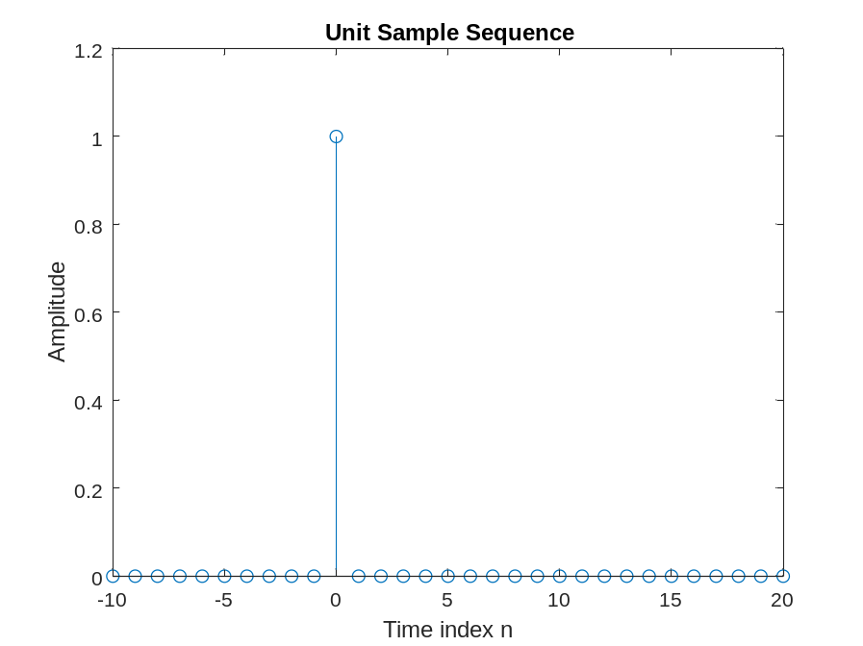

Q1.2 The purpose of clf command is Clear current figure
The purpose of axis command is specifies the limits for the current axes.
The purpose of title command is adds the specified title to the axes or chart
The purpose of xlabel command is labels the x-axis of the current axes or chart
The purpose of ylabel command is labels the y-axis of the current axes or chart
Q1.3 The modified Program P1_1 to generate a delayed unit sample sequence ud[n] with a delay of 11 samples is given below along with the sequence generated by running this program.
% Program Q1.3
% Generation of a Unit Sample Sequence
clf;
% Generate a vector from -10 to 20
n = -10:20;
% Generate the unit sample sequence
u = [zeros(1,21) 1 zeros(1,9)];
% Plot the unit sample sequence
stem(n,u);
xlabel('Time index n');ylabel('Amplitude');
title('Unit Sample Sequence');

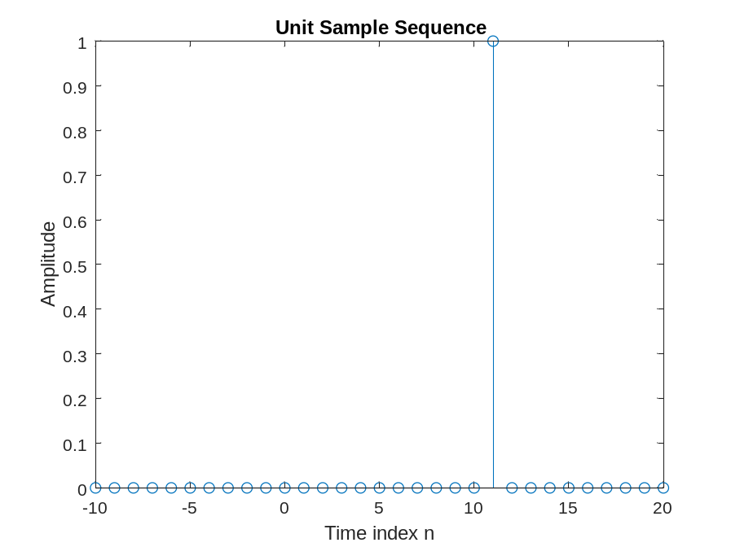
Q1.4 The modified Program P1_1 to generate a unit step sequence s[n] is given below along with the sequence generated by running this program.
% Program Q1.4
% Generation of a Unit Sample Sequence
clf;
% Generate a vector from -10 to 20
n = -10:20;
% Generate the unit sample sequence
s = [zeros(1,10) ones(1,21)];
% Plot the unit sample sequence
stem(n,s);
xlabel('Time index n');ylabel('Amplitude');
title('Unit Sample Sequence');
axis([-10 20 0 1.2]);

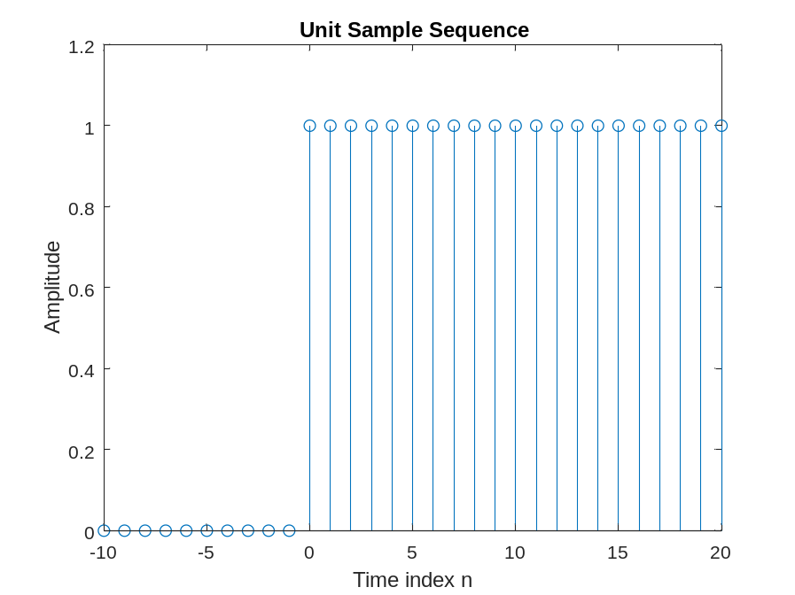
Q1.5 The modified Program P1_1 to generate a unit step sequence sd[n] with an advance of 7 samples is given below along with the sequence generated by running this program.
% Program Q1.5
% Generation of a Unit Sample Sequence
clf;
% Generate a vector from -10 to 20
n = -10:20;
% Generate the unit sample sequence
u = [zeros(1,3) ones(1,28)];
% Plot the unit sample sequence
stem(n,u);
xlabel('Time index n');ylabel('Amplitude');
title('Unit Sample Sequence');
axis([-10 20 0 1.2]);

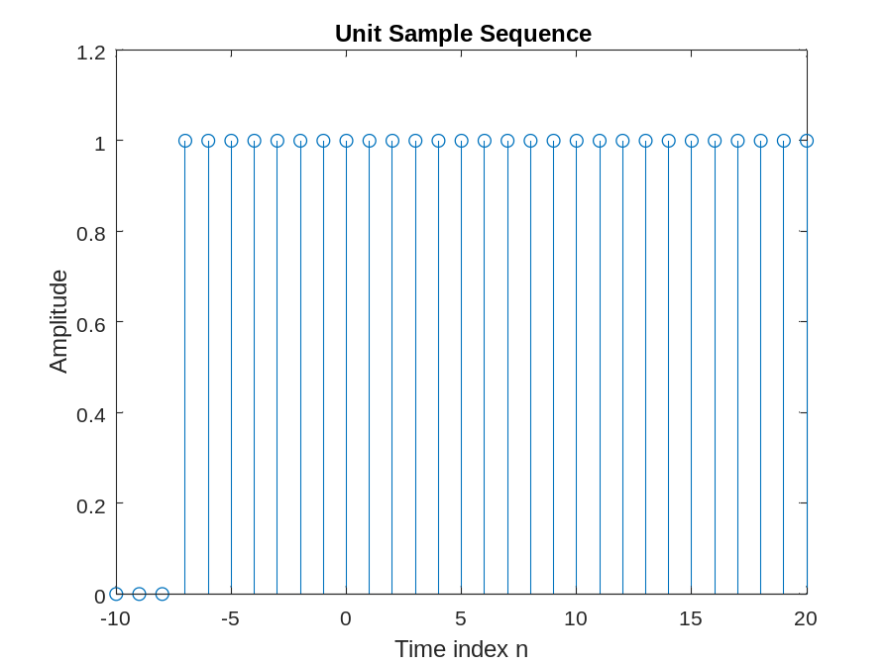
Project 1.2 Exponential signals
A copy of Programs P1_2 and P1_3 are given below.
% Program P1_2
% Generation of a complex exponential sequence
clf;
c = -(1/12)+(pi/6)*i;
K = 2;
n = 0:40;
x = K*exp(c*n);
subplot(2,1,1);
stem(n,real(x));
xlabel('Time index n');ylabel('Amplitude');
title('Real part');
subplot(2,1,2);
stem(n,imag(x));
xlabel('Time index n');ylabel('Amplitude');
title('Imaginary part');
% Program P1_3
% Generation of a real exponential sequence
clf;
n = 0:35; a = 1.2; K = 0.2;
x = K*a.^n;
stem(n,x);
xlabel('Time index n');ylabel('Amplitude');

Answers:
Q1.6 The complex-valued exponential sequence generated by running Program P1_2 is shown below:
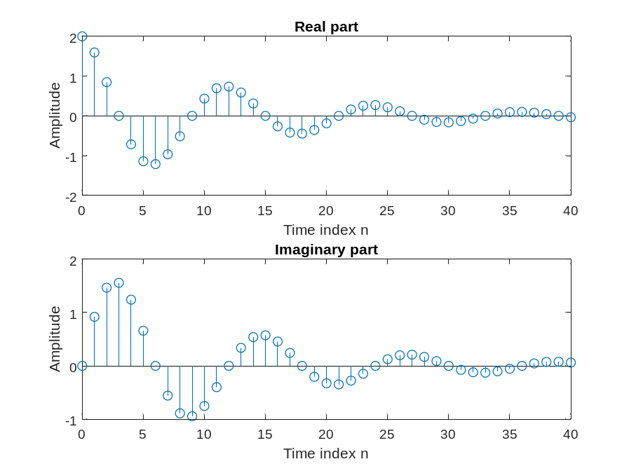
Q1.7 The parameter controlling the rate of growth or decay of this sequence is c
The parameter controlling the amplitude of this sequence is k
Q1.8 The result of changing the parameter c to (1/12)+(pi/6)*i is the growth rate decreased.
Q1.9 The purpose of the operator real is find the real part of each element in vector
The purpose of the operator imag is find the imaginary part of each element in vector
Q1.10 The purpose of the command subplot is divides the current figure into an m-by-n grid and creates axes in the position specified by p.
Q1.11 The real-valued exponential sequence generated by running Program P1_3 is shown below:
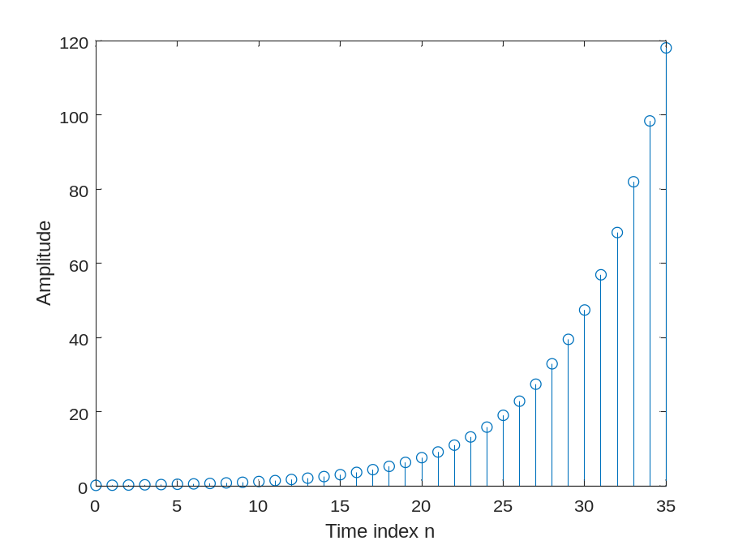
Q1.12 The parameter controlling the rate of growth or decay of this sequence is a
The parameter controlling the amplitude of this sequence is k
Q1.13 The difference between the arithmetic operators ^ and .^ is “^” raises a square matrix to a power using matrix multiplication. “.^” raises the elements of a matrix or vector to a power
Q1.14 The sequence generated by running Program P1_3 with the parameter a changed to 0.9 and the parameter K changed to 20 is shown below:
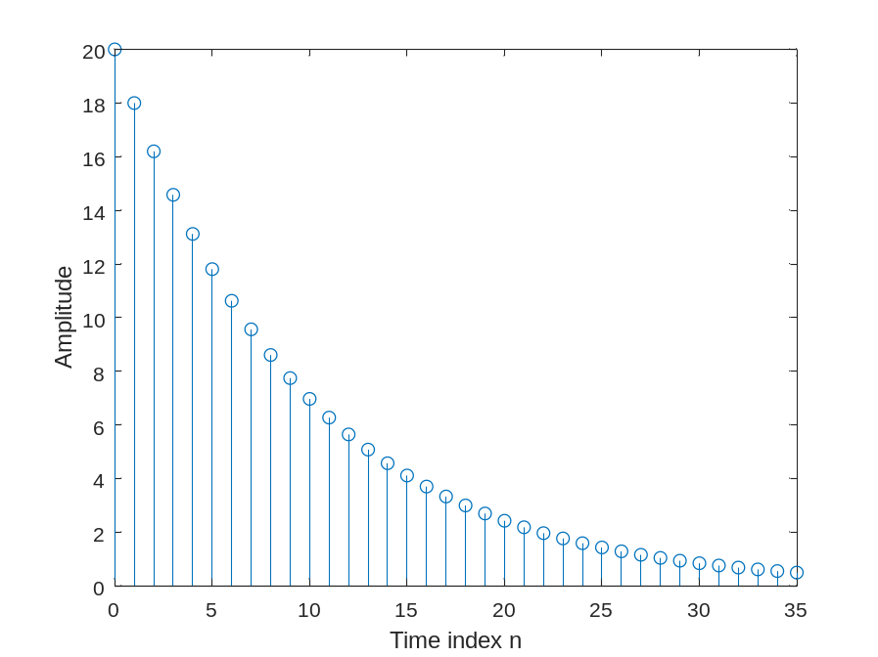
Q1.15 The length of this sequence is 35
It is controlled by the following MATLAB command line: stem(n,x)
It can be changed to generate sequences with different lengths as follows (give an example command line and the corresponding length): n = 0:50; The length of this sequence is 51
Q1.16 The energies of the real-valued exponential sequences x[n]generated in Q1.11 and Q1.14 and computed using the command sum are Ex = sum(x.*x);
Project 1.3 Sinusoidal sequences
A copy of Program P1_4 is given below.
% Program P1_4
% Generation of a sinusoidal sequence
n = 0:40;
f = 0.1;
phase = 0;
A = 1.5;
arg = 2*pi*f*n - phase;
x = A*cos(arg);
clf; % Clear old graph
stem(n,x); % Plot the generated sequence
axis([0 40 -2 2]);
title('Sinusoidal Sequence');
xlabel('Time index n');
ylabel('Amplitude');
grid; axis;
Answers:
Q1.17 The sinusoidal sequence generated by running Program P1_4 is displayed below.
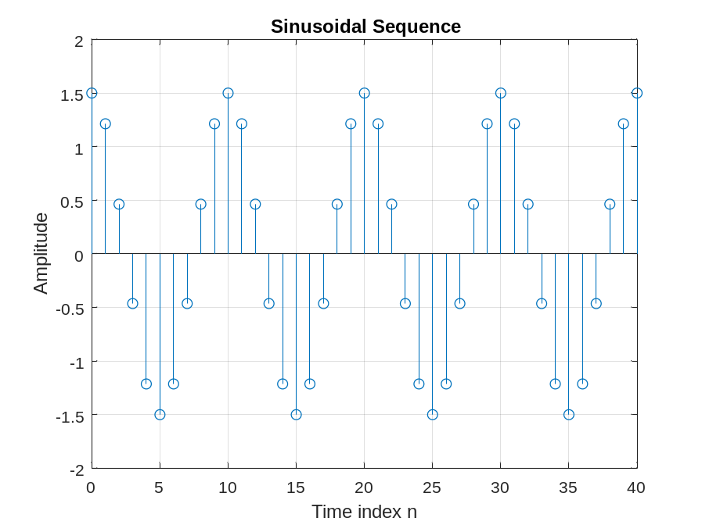
Q1.18 The frequency of this sequence is 0.1Hz
It is controlled by the following MATLAB command line: f = 0.1;
A sequence with new frequency 0.9 Hz can be generated by the following command line:
f = 0.9;
The parameter controlling the phase of this sequence is phase
The parameter controlling the amplitude of this sequence is A
The period of this sequence is T= 1/f = 1/0.1 = 10s

Q1.19 The length of this sequence is 41
It is controlled by the following MATLAB command line: n = 0:40;
A sequence with new length 32 can be generated by the following command line:
n = 0:31;
Q1.20 The average power of the generated sinusoidal sequence is 0

Q1.21 The purpose of axis command is specifies the limits for the current axes
The purpose of grid command is on displays the major grid lines for the current axes or chart
Q1.22 The modified Program P1_4 to generate a sinusoidal sequence of frequency 0.9 is given below along with the sequence generated by running it.
% Program Q1.22
% Generation of a sinusoidal sequence
n = 0:40;
f = 0.9;
phase = 0;
A = 1.5;
arg = 2*pi*f*n - phase;
x = A*cos(arg);
clf; % Clear old graph
stem(n,x); % Plot the generated sequence
axis([0 40 -2 2]);
grid;
title('Sinusoidal Sequence');
xlabel('Time index n');
ylabel('Amplitude');
axis;
A comparison of this new sequence with the one generated in Question Q1.17 shows the graph does not change
A sinusoidal sequence of frequency 1.1 generated by modifying Program P1_4 is shown below.
A comparison of this new sequence with the one generated in Question Q1.17 shows the graph does not change
Q1.23 The sinusoidal sequence of length 50, frequency 0.08, amplitude 2.5, and phase shift of 90 degrees generated by modifying Program P1_4 is displayed below.
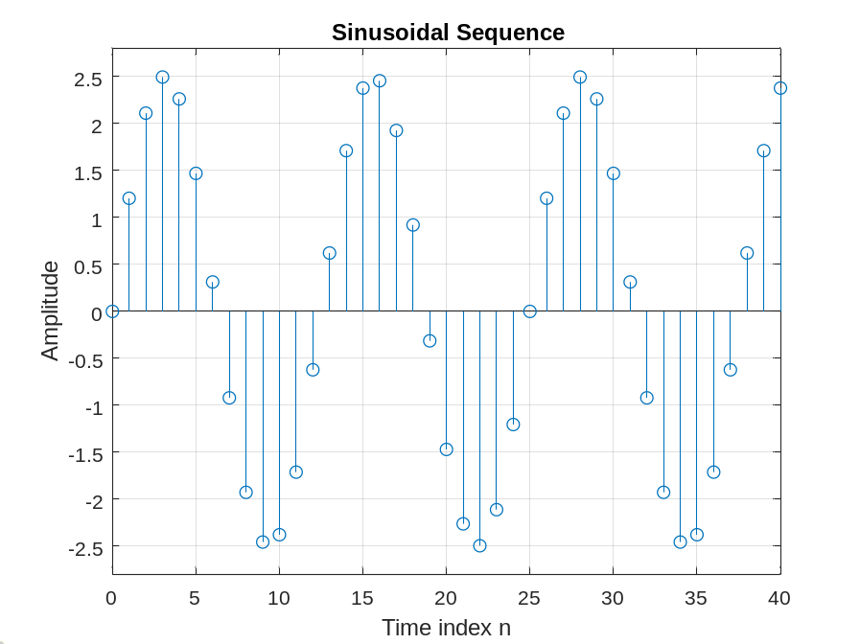
The period of this sequence is 12.5
Q1.24 By replacing the stem command in Program P1_4 with the plot command, the plot obtained is as shown below:
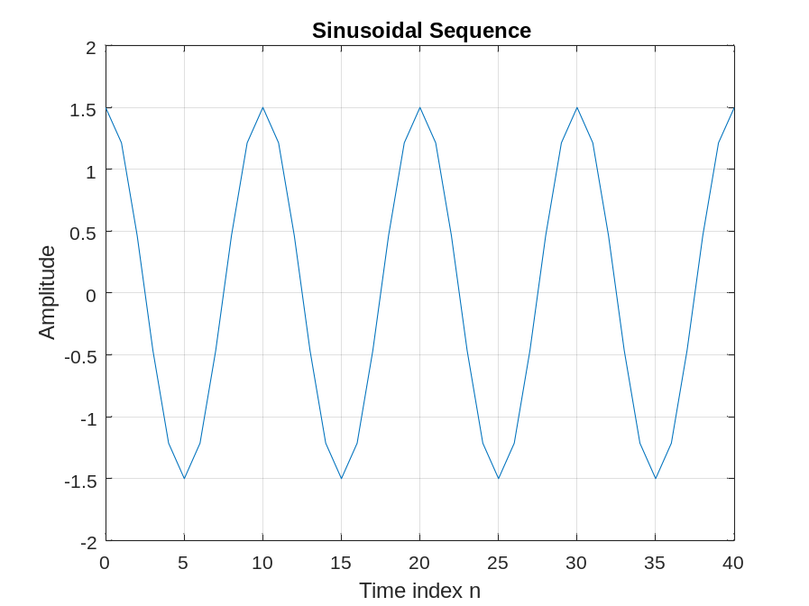
The difference between the new plot and the one generated in Question Q1.17 is the graph is
a continuous signal
Q1.25 By replacing the stem command in Program P1_4 with the stairs command the plot obtained is as shown below:
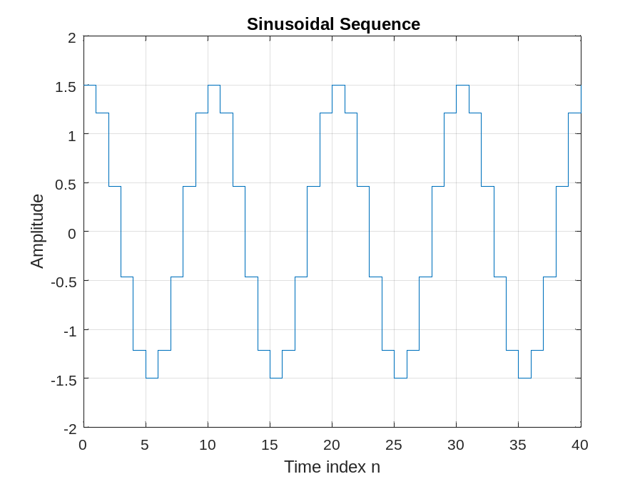
The difference between the new plot and those generated in Questions Q1.17 and Q1.24 is the hold sampling signal
Project 1.4 Random signals
Answers:
Q1.26 The MATLAB program to generate and display a random signal of length 100 with elements uniformly distributed in the interval [–2, 2] is given below along with the plot of the random sequence generated by running the program:
% Program Q1_26
n=1:100;
x = -2 + (2+2)*rand(100,1);
stem(n,x);
title('Q1.26');
xlabel('Time index n');
ylabel('Value');
axis([1 100 -2.2 2.2]);
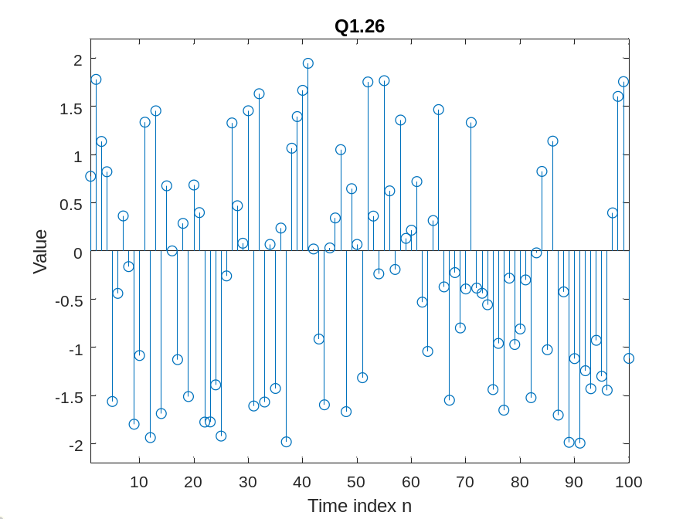
Q1.27 The MATLAB program to generate and display a Gaussian random signal of length 75 with elements normally distributed with zero mean and a variance of 3 is given below along with the plot of the random sequence generated by running the program:
% Program Q1.27
clf;
n=0:74;
expected = 0;
variance = 3;
x = sqrt(variance) * randn(1,75) + expected;
stem(n,x);
axis([0 75 -5 5]);
title('Gaussian Random Sequence');
xlabel('Time index n');
ylabel('Amplitude');
grid;axis;
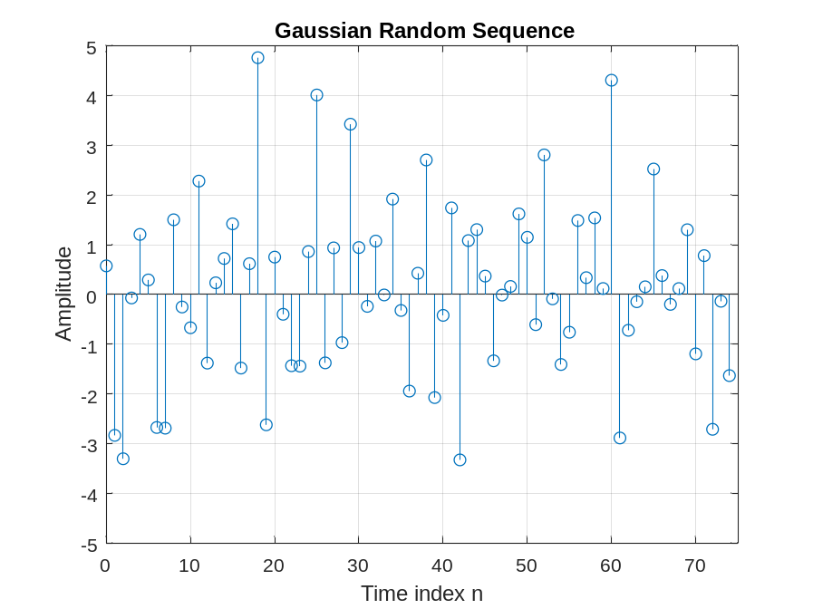
Q1.28 The MATLAB program to generate and display five sample sequences of a random sinusoidal signal of length 31
{X[n]} = {Acos(ωon + φ)}
where the amplitude A and the phase φ are statistically independent random variables with uniform probability distribution in the range for the amplitude and in the range 0 ≤ φ ≤ 2π for the phase is given below. Also shown are five sample sequences generated by running this program five different times.
% Program Q1.28
n=0:30;
f=0.1;
A = 4*rand;
phi = 2*pi*rand;
arg = 2*pi*f*n + phi;
x = A*cos(arg);
stem(n, x);
axis([0 31 -4.5 4.5]);
title('Sinusoidal Sequence with Random Amplitude and Phase');
xlabel('Time index n');
ylabel('Amplitude');
grid;
axis;
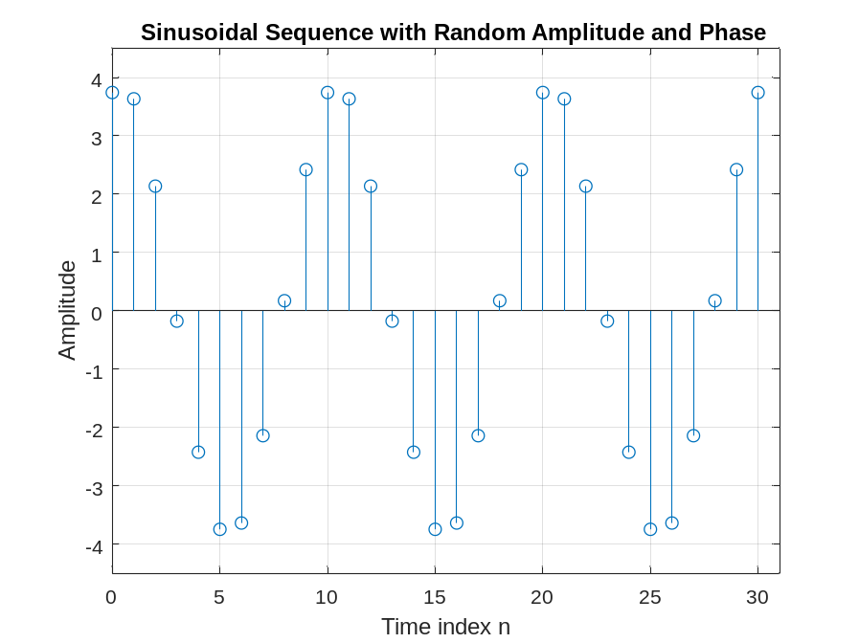
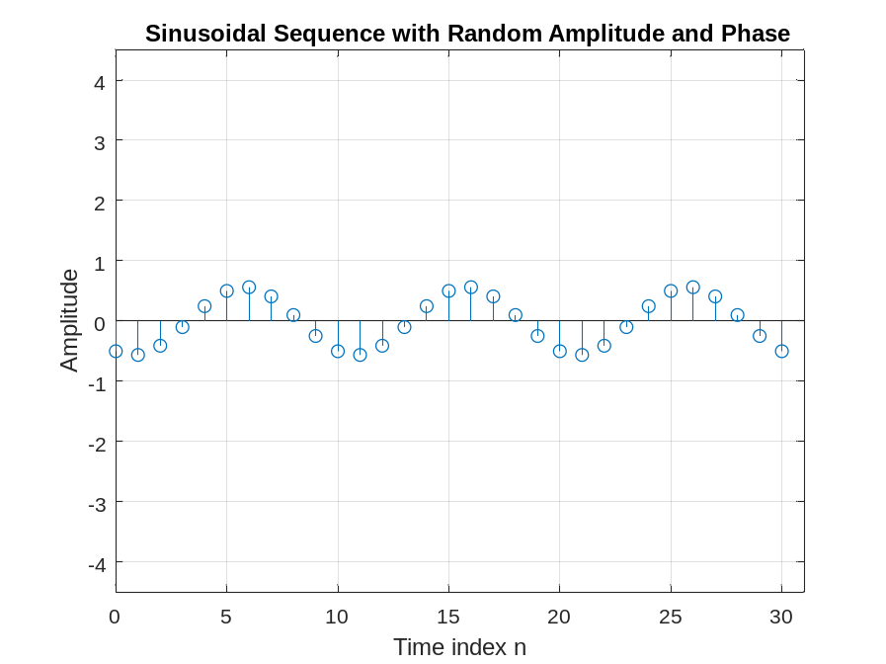
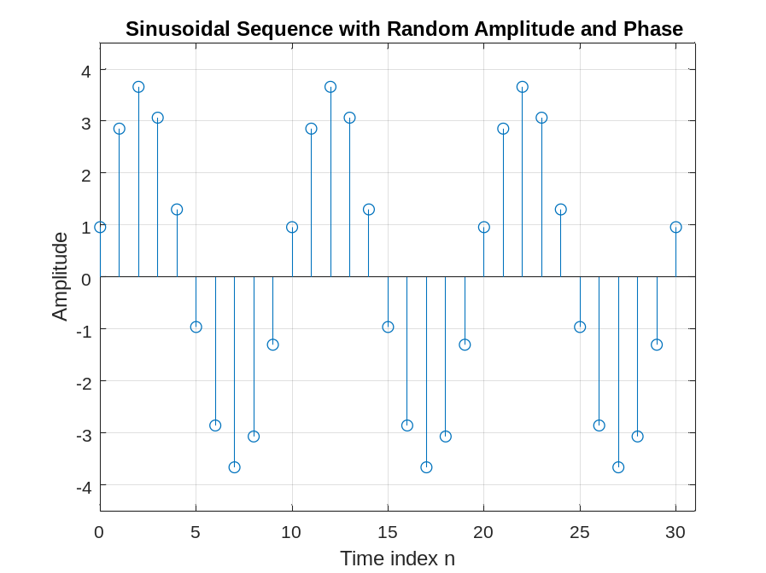
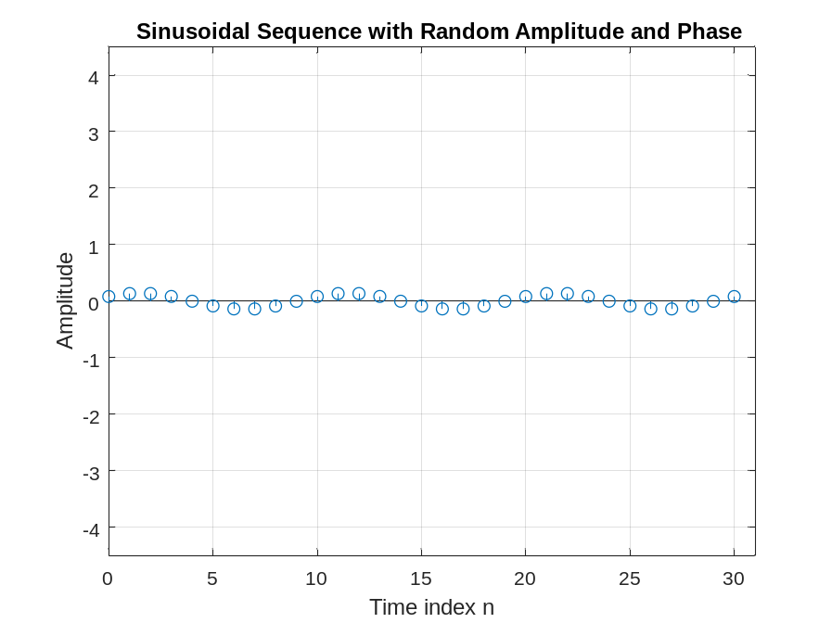
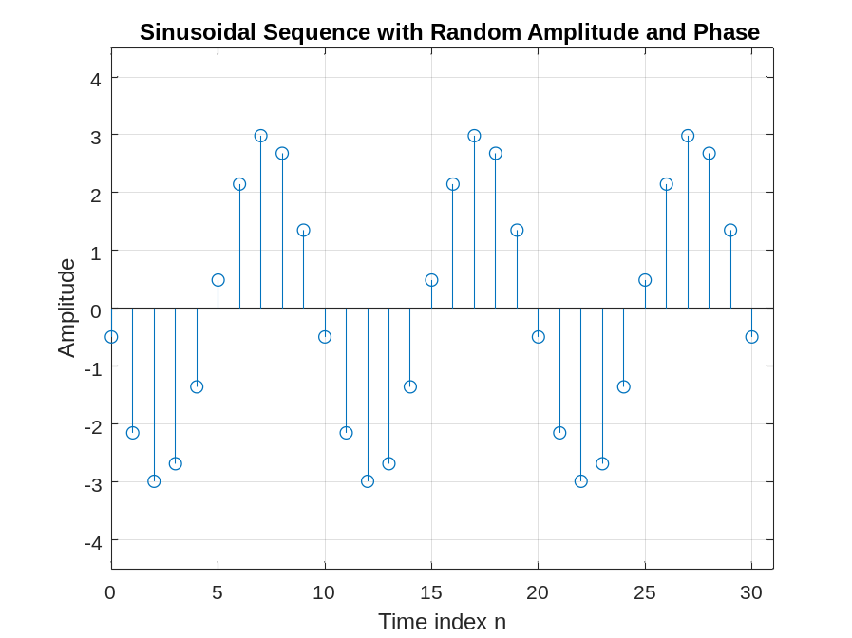
1.2 SIMPLE OPERATIONS ON SEQUENCES
Project 1.5 Signal Smoothing
A copy of Program P1_5 is given below.
% Program P1_5
% Signal Smoothing by Averaging
clf;
R = 51;
d = 0.8*(rand(R,1) - 0.5); % Generate random noise
m = 0:R-1;
s = 2*m.*(0.9.^m); % Generate uncorrupted signal
x = s + d'; % Generate noise corrupted signal
subplot(2,1,1);
plot(m,d','r-',m,s,'g--',m,x,'b-.');
xlabel('Time index n');ylabel('Amplitude');
legend('d[n] ','s[n] ','x[n] ');
x1 = [0 0 x];x2 = [0 x 0];x3 = [x 0 0];
y = (x1 + x2 + x3)/3;
subplot(2,1,2);
plot(m,y(2:R+1),'r-',m,s,'g--');
legend( 'y[n] ','s[n] ');
xlabel('Time index n');ylabel('Amplitude');
Answers:
Q1.29 The signals generated by running Program P1_5 are displayed below:
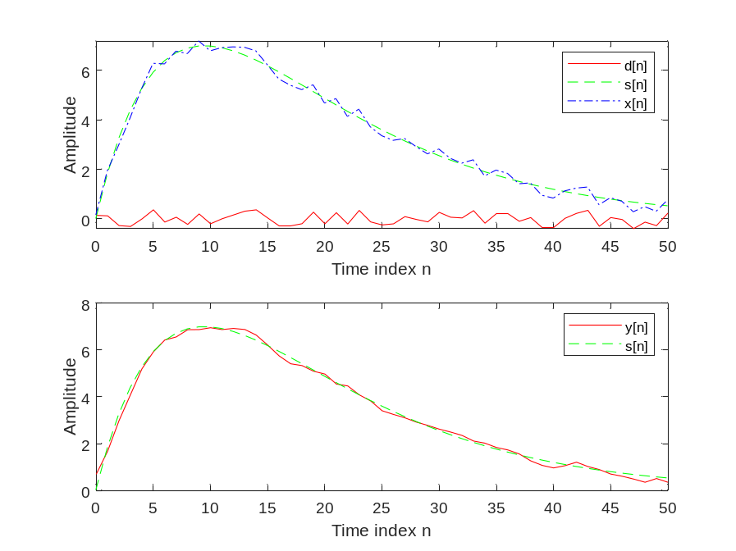
Q1.30 The uncorrupted signal s[n]is a linear decay function with the rate of decay of this sequence is 0.9
The additive noise d[n]is a random sequence with amplitude for -0.4 to 0.4
Q1.31 The statement x = s + d CANNOT be used to generate the noise corrupted signal because d is a column vector, whereas s is a row vector; it is necessary to transpose one of these vectors before adding them.
Q1.32 The relations between the signals x1, x2, and x3, and the signal x are extended versions of x, with one additional sample appended at the left and one additional sample appended to the right. The signal x1 is a delayed version of x, shifted one sample to the right with zero padding on the left. The signal x2 is equal to x, with equal zero padding on both the left and right to account for the extended length. Finally, x3 is a time advanced version of x, shifted one sample to the left with zero padding on the right.
Q1.33 The purpose of the legend command is used creates a legend with descriptive labels for each plotted data series
Project 1.6 Generation of Complex Signals
A copy of Program P1_6 is given below.
% Program P1_6
% Generation of amplitude modulated sequence
clf;
n = 0:100;
m = 0.4;fH = 0.1; fL = 0.01;
xH = sin(2*pi*fH*n);
xL = sin(2*pi*fL*n);
y = (1+m*xL).*xH;
stem(n,y);grid;
xlabel('Time index n');ylabel('Amplitude');
Answers:
Q1.34 The amplitude modulated signals y[n] generated by running Program P1_6 for various values of the frequencies of the carrier signal xH[n] and the modulating signal xL[n], and various values of the modulation index m are shown below:
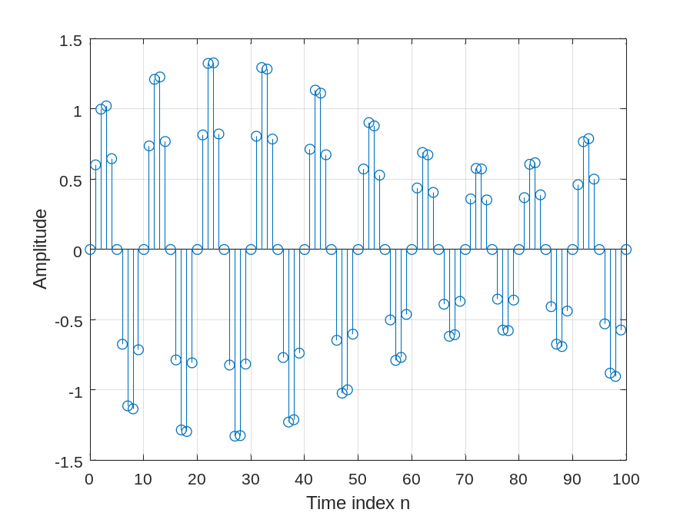
Q1.35 The difference between the arithmetic operators * and .* is “*” used to multiply 2 matrices or vector, “.*” used to multiply two points withs the same coordinates
A copy of Program P1_7 is given below.
% Program P1_7
% Generation of a swept frequency sinusoidal sequence
n = 0:100;
a = pi/2/100;
b = 0;
arg = a*n.*n + b*n;
x = cos(arg);
clf;
stem(n, x);
axis([0,100,-1.5,1.5]);
title('Swept-Frequency Sinusoidal Signal');
xlabel('Time index n');
ylabel('Amplitude');
grid; axis;
Answers:
Q1.36 The swept-frequency sinusoidal sequence x[n] generated by running Program P1_7 is displayed below.
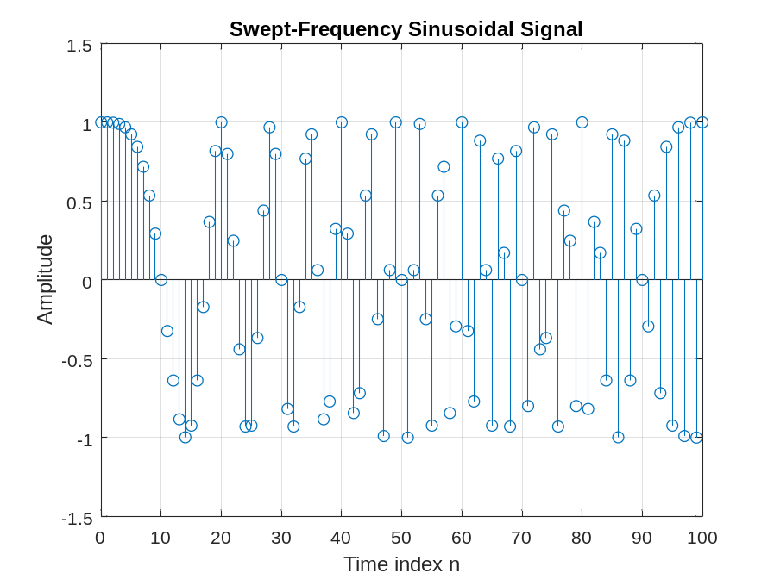
Q1.37 The minimum and maximum frequencies of this signal are the minimum occurs at n=0 where we have 2an + b = 0 rad/sample = 0 Hz. The maximum occurs at n = 100 where we have 2an + b = 200a = 200*pi (0.5) (0.01) = pi rad/sample = 0.5 Hz
Q1.38 The Program 1_7 modified to generate a swept sinusoidal signal with a minimum frequency of 0.1 and a maximum frequency of 0.3 is given below:
% Program Q1.38
% Generation of a swept frequency sinusoidal sequence
%f=0.1 => 2*pi*f=pi/5
%f=0.3 => 2*pi*f=3pi/5
%n=0 => b=pi/5
%n=100 => 2an+b = 3pi/5 => a = pi/500
n = 0:100;
a = pi/500;
b = pi/5;
arg = a*n.*n + b*n;
x = cos(arg);
clf;
stem(n, x);
axis([0,100,-1.5,1.5]);
title('Swept-Frequency Sinusoidal Signal');
xlabel('Time index n');
ylabel('Amplitude');
grid; axis;
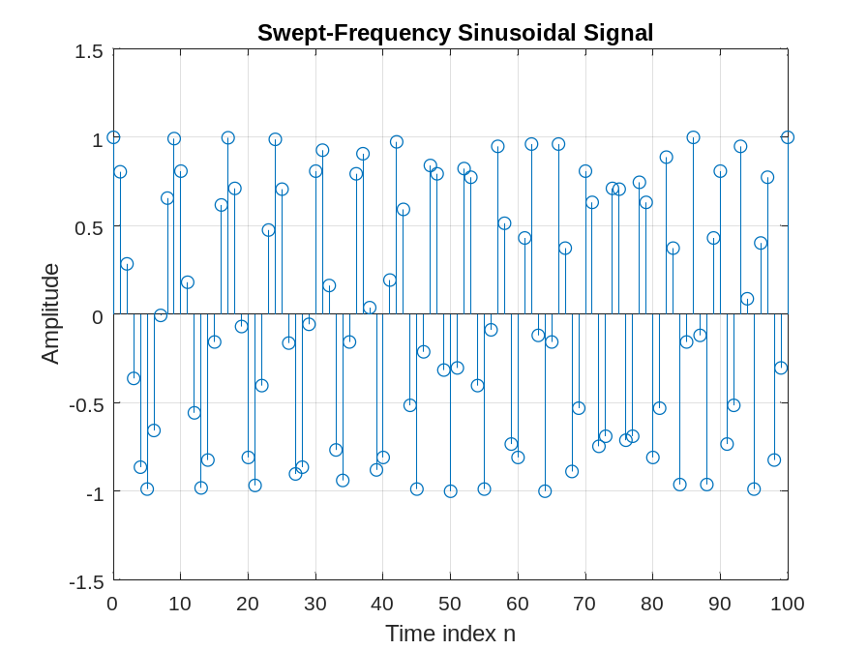
1.3 WORKSPACE INFORMATION
Q1.39 The information displayed in the command window as a result of the who command is lists in alphabetical order the names of all variables in the currently active workspace.
Q1.40 The information displayed in the command window as a result of the whos command is lists in alphabetical order the names, sizes, and types of all variables in the currently active workspace.
1.4 OTHER TYPES OF SIGNALS (Optional)
Project 1.8 Squarewave and Sawtooth Signals
Answer:
Q1.41 MATLAB programs to generate the square-wave and the sawtooth wave sequences of the type shown in Figures 1.1 and 1.2 are given below along with the sequences generated by running these programs:
% Program Q1_41_Figure_1.1a
% Generation of a sinusoidal sequence
n = 0:30;
f = 0.1;
phase = 0;
A = 2.5;
duty = 60;
arg = 2*pi*f*n - phase;
x = A*square(arg,duty);
clf; % Clear old graph
stem(n,x); % Plot the generated sequence
axis([0 30 -2.8 2.8]);
grid;
title('Sinusoidal Sequence Figure_1.1a');
xlabel('Time index n');
ylabel('Amplitude');
axis;
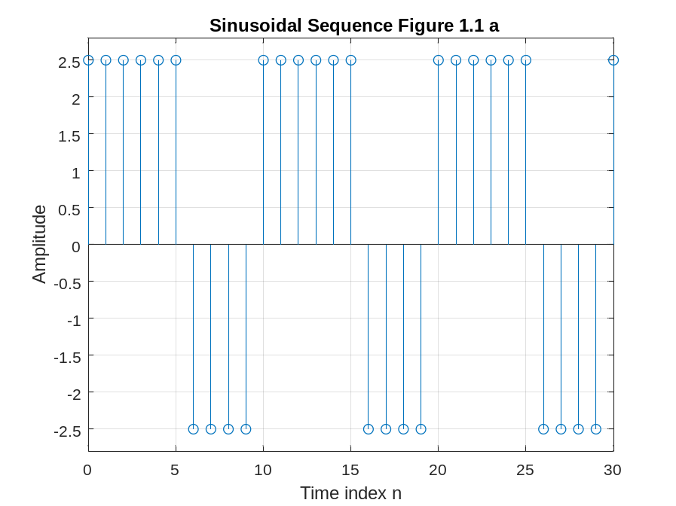
% Program Q1_41_Figure_1.1b
% Generation of a sinusoidal sequence
n = 0:30;
f = 0.1;
phase = 0;
A = 2.5;
duty = 30;
arg = 2*pi*f*n - phase;
x = A*square(arg,duty);
clf; % Clear old graph
stem(n,x); % Plot the generated sequence
axis([0 30 -2.8 2.8]);
grid;
title('Sinusoidal Sequence Figure 1.1 b');
xlabel('Time index n');
ylabel('Amplitude');
axis;
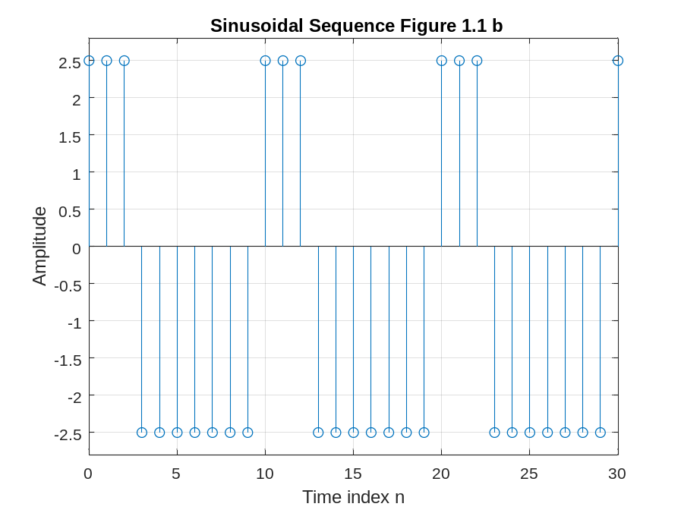
% Program Q1_41_Figure_1.2a
% Generation of a sinusoidal sequence
n = 0:50;
f = 0.05;
phase = 0;
A = 2;
arg = 2*pi*f*n - phase;
x = A*sawtooth(arg);
clf; % Clear old graph
stem(n,x); % Plot the generated sequence
axis([0 50 -2.2 2.2]);
grid;
title('Sinusoidal Sequence Figure 1.2 a');
xlabel('Time index n');
ylabel('Amplitude');
axis;
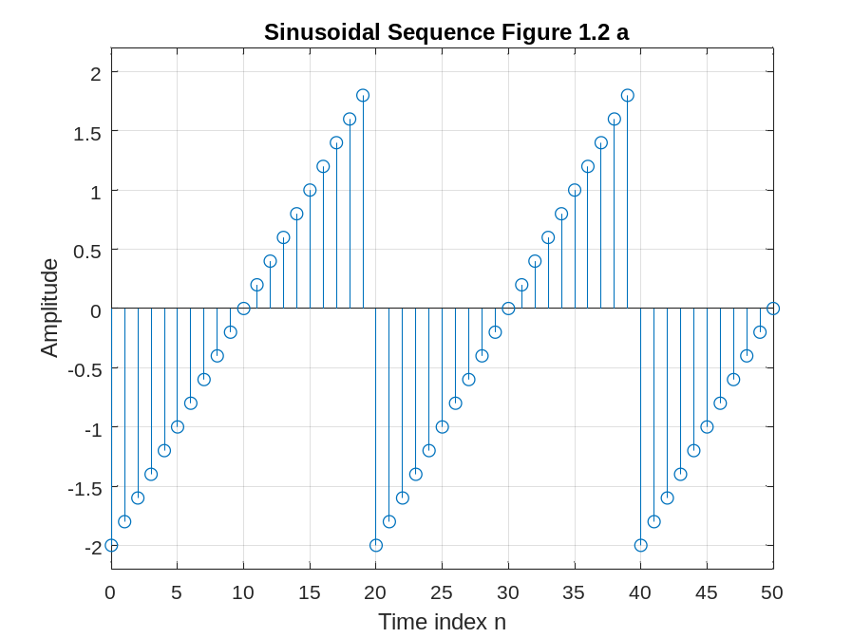
% Program Q1_41_Figure_1.2b
% Generation of a sinusoidal sequence
n = 0:50;
f = 0.05;
phase = 0;
A = 2;
arg = 2*pi*f*n - phase;
x = A*sawtooth(arg,1/2);
clf; % Clear old graph
stem(n,x); % Plot the generated sequence
axis([0 50 -2.2 2.2]);
grid;
title('Sinusoidal Sequence Figure 1.2 b');
xlabel('Time index n');
ylabel('Amplitude');
axis;

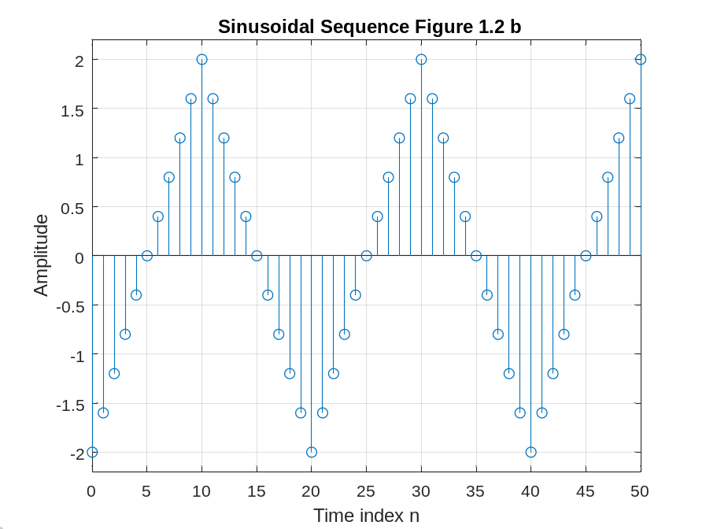
Date: 11/9/2024 Signature: Nguyễn Đình Khánh Vy

